**The report on “Hate Speech in Southeast Asia: New Forms, Old Rules**

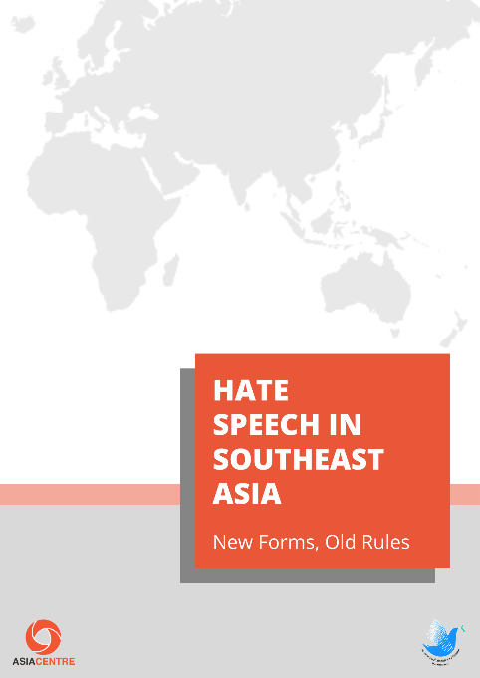

The Thai Media Fund supports Asia Centre in doing a report “Hate Speech in Southeast Asia: New Forms, Old Rules,” which is one of the projects under the 2019 Memorandum of Cooperation (MOC) between Thai Media Fund and Asia Centre.

The report describes the status quo and current issues leading to discrimination, violence, and communal strife in the region. It examines the legal framework, in particular, a slew of “harmony” bills aimed at securing social, racial or religious harmony as well as non – legal measures to foster social cohesion, interfaith dialogues, and social harmony.

It also evaluates states in Southeast Asia that signed the International Convention on the Elimination of All Forms of Racial Discrimination (ICERD). The study recommends a range of measures to alleviate the challenges arising from hate speech. Among them is a primary recommendation to officially recognize newer forms of hate speech and a set of secondary recommendations to promote understanding and diversity.

TMF strongly supports and promotes digital and media literacy in Thai society with the aim to accomplish its vision which is “People can access, understand and be able to use media wisely, safely and constructively within a good media ecosystem”.